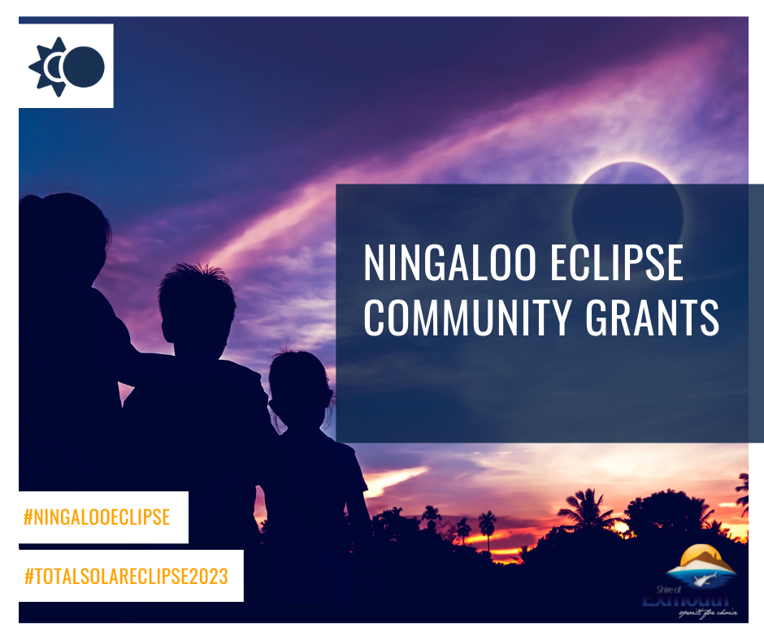
Contents
Introduction 2
Eligibility requirements 2
Ineligible Applications 2
Priority Areas 2
Assessment criteria 2
Conditions of funding 2
Event approvals 3
Section 1: Organisation information 3
Section 2: Project information 3
Section 3: Budget 4
Section 4: Signing and checklist 5
Section 5: Declaration 5

Ningaloo Eclipse Community Grants Program

Introduction
The Shire of Exmouth invites applications from eligible local Incorporated Community & Sporting Groups to support them in preparation for the Ningaloo Eclipse on 20 April 2023.
Round 1 Opens 30 September 2022
Closes 11 November 2022

Late applications will not be considered.

Eligibility requirements
Funding is available only to not-for-profit and incorporated community or sporting organisations based in the Shire of Exmouth.

Ineligible Applications
The Shire will not fund the following:
- Retrospective or deficit funding;
- Recurrent expenditure such as salaries, wages, electricity, insurance, water, rates and other core organisational operating costs;
- Fees associated with administering the grant funding;
- Government or quasi-government agencies excluding local schools.

Priority Areas
- Food and Beverage supply and service
- Place activation
- Events
- Temporary camping facilities

Assessment criteria
To be eligible for assessment, applications must be for activities during the Ningaloo Eclipse and preference will be given to initiatives that have legacy benefits to the club or groups.
Applications for NECGP funding will be assessed by a panel consisting of Chief Executive Officer (or delegated representative) plus two Shire Councillors. The panel will assess applications in each round against the following criteria;
- The application addresses a priority area for the Exmouth Community during the Ningaloo Eclipse (see above).
- Legacy benefits to the club or group.
- Demonstrated value for money.
Applicants should answer all questions provided with as much detail as necessary. When completing the application form, consider how your proposed activity addresses the criteria above. Indicative quotes for budget items are encouraged.

Conditions of funding
Successful applicants will be required to sign a funding agreement with the Shire outlining conditions of funding that may include but are not limited to;
- Recognition of the Shire as an event sponsor/partner in all publicity material associated with the event, e.g. social media, print and digital advertising, posters and other marketing material, and opportunity to preview/proof the items/documents prior to distribution.
- Signage and other marketing material displayed at event/program/project.

A funding agreement may be refused and/or terminated if deemed by the Chief Executive Officer as a real or perceived conflict, or where a breach of the terms of an agreement has occurred.

Event approvals
Applicants who receive funding to deliver and organise an event must still seek all relevant approvals from the Shire of Exmouth.

APPLICATION FORM

Please ensure that you have read the Ningaloo Eclipse guidelines above before completing the attached application form. We also recommend you contact the Shire of Exmouth Community Development Officer via info@exmouth.wa.gov.au to discuss your project before applying.
Please note that organisations and individuals are only eligible to submit one application across all Shire of Exmouth funding and sponsorship categories for each project.

Section 1: Organisation information
Name of organisation
Contact person
Address
Phone number
Email

I have read the NE funding guidelines

My organisation is eligible to apply for this funding

Does your organisation have an Australian Business Number?

*If yes, please include ABN here
Is your organisation registered for GST?

Has your organisation been granted deductible recipient status?

Are you an employee or contractor working for the Shire of Exmouth or a close relative?
*If yes, we will contact you to determine any potential conflict of interest

Section 2: Project information
Project name
Project dates
Location of project/s

Briefly describe the project. (max 200 words)
Provide an overview of how your project will have a legacy benefit to your organisation (200 words or less).
What experience has your organisation had with similar projects?
Does your event hold at least $20 million public liability insurance?

Please list key people from your organisation who will be involved in organising this project
Name | Position/roll | Time with organisation

Section 3: Budget
Please provide an overview of the budget for specific initiative that your organisation is requesting funding for.
Initiative income |  | Initiative costs
Item | Cost | Provide breakdown of total budget |  | Cost
Funds requested from Shire  (including GST) |  | Salaries, fees and wages (including on costs)
In-kind or cash support from your organisation |  | Administration expenses (office costs, phone, fax, etc.)
Government grants / contribution |  | Travel (flights, accommodation, mileage, etc.)
Other funds |  | Logistics (equipment, venue hire, freight, etc.)
Other |  | Research
 |  | Advertising and promotion
 |  | Program contingency
 |  | Other
#TOTAL PROGRAM FUNDS  #These amounts should be equal |  | #TOTAL PROGRAM COSTS
Shire of Exmouth funding request. Please provide a detailed breakdown of how Shire of Exmouth funding will be spent.
Item |  |  | Cost

Section 4: Signing and checklist
ABN attached (if applicable)

Copy public liability insurance attached

Project budget completed

Application to be submitted in WORD or PDF format only

Section 5: Declaration
I, the undersigned, being the ( insert title) of (organisation name), confirm that I am authorised by the committee to apply for this funding and I have carefully reviewed and considered the responses and the information provided is true and correct.

Signed Date: Click or tap to enter a date.

Completed applications should be mailed or submitted in person to:
Shire of Exmouth
Ningaloo Eclipse Community Grant Program
2 Truscott Cres
EXMOUTH WA 6707

Electronic submissions should be emailed to info@exmouth.wa.gov.au with subject line: Ningaloo Eclipse Community Grant Program

