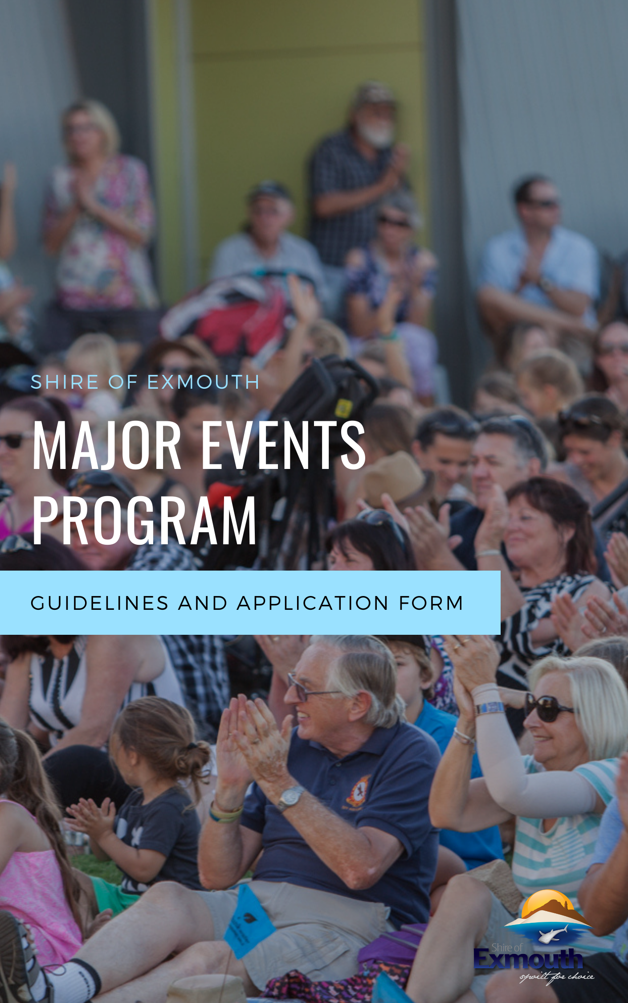

Table of Contents

# Major Events Funding Program

Major Events Funding Program 2

Introduction 3

What is a Major Event? 3

Eligibility requirements 3

Assessment criteria 4

Conditions of funding 4

Event approvals 4

Section 1: Organisation information 5

Section 2: Event information 6

Section 3: Economic impact estimates: 7

Section 4: Community support 7

Section 5: Marketing and communications 8

Section 6: Budget 8

Section 7: Evaluation 9

Section 8: Signing and checklist 9

Section 9: Declaration 10

Major Events Sponsorship Program

# Introduction

The Shire of Exmouth’s annual Major Events Sponsorship Program (MESP) for the 2021-2022 financial year offers grants of up to $5,000 ex GST to eligible organisations to support the delivery of events that have significant economic benefit to the Exmouth community.

Applications can be made at any time and will be assessed until the funding pool is extinguished. Applications should be submitted using the nominated Shire of Exmouth form.

Established and/or proven events can apply for multi-year support up to $5,000 ex GST per event per annum for a three (3) year period.

Applicants are encouraged to contact Shire of Exmouth officers to discuss their application before making formal submissions.

# What is a Major Event?

The Major Events Sponsorship program supports special events including business tourism that can provide an economic benefit to the community. Eligible events include, but are not limited to sporting, recreational, music, cultural, food and wine, and business conferences that have the potential to attract significant numbers from outside the region and to ultimately generate new additional expenditure into the Exmouth economy.

Events should deliver outcomes including:

* Tourism destination development;
* Drive overnight visitation;
* Attract visitors during tourist season shoulder and low periods;
* Activate public places; and/or
* Engage regional communities.

# Eligibility requirements

Funding is available to not-for-profit incorporated organisations, and commercial organisations that can clearly demonstrate their event will deliver significant additional economic benefit to the Exmouth region.

Events must be delivered in shoulder or low visitor periods. Any event delivered during peak periods (defined as Easter holidays, April and July WA school holidays) will not be eligible for MESP sponsorship support.

Events must take place on or before 30 June 2022. Funding cannot be granted retrospectively.

Commercial (for profit) event organisers will be required to submit a formal sponsorship application that will require Council consideration and approval.

# Assessment criteria

Applications will be assessed based on their ability to deliver:

* Economic benefits to the Exmouth destination;
* Destination promotion;
* Legacy benefits.

Letters of support for the proposed activity will be viewed favourably and indicative quotes for budget items are strongly encouraged.

Applicants will be advised of the outcome of their application within 6 weeks of receiving the application, assuming Council resolution is not required. If a Council resolution is required, applicants will be advised.

# Conditions of funding

Successful applicants will be required to sign a sponsorship agreement with the Shire outlining conditions of sponsorship that may include but are not limited to;

* Recognition of the Shire as an event sponsor in all publicity material associated with the event, e.g. social media, print and digital advertising, posters and other marketing material, and opportunity to preview/proof the items/documents prior to distribution.
* Opportunity for the Shire to attend events as sponsor, speak at official ceremonies and access participants;
* Signage and other marketing material displayed at event-provided by the Shire of Exmouth or its entities.

A sponsorship agreement may be refused and/or terminated if deemed by the Chief Executive Officer as a real or perceived conflict, or where a breach of the terms of an agreement has occurred.

# Event approvals

Applicants who receive sponsorship funding to deliver and organise an event must still seek all relevant approvals from the Shire of Exmouth.

Application form

Please ensure that you have read the Major Events Sponsorship Program (MESP) guidelines before completing the attached application form. We also recommend you contact Shire of Exmouth Community Service team via [info@exmouth.wa.gov.au](mailto:info@exmouth.wa.gov.au) to discuss your event before applying.

Please note that organisations and individuals are only eligible to submit one application across all Shire of Exmouth funding and sponsorship categories for each project.

# Section 1: Organisation information

|  |  |
| --- | --- |
| Name of organisation |  |
| Contact person/position |  |
| Address |  |
| Phone number |  |
| E-mail |  |
| Bank details for direct debit | BSB       Acc |
|  | Branch |

|  |  |
| --- | --- |
| I have read the Major Events Sponsorship Program funding guidelines |  |
| My organisation is eligible to apply for this funding |  |
| Does your organisation have an Australian Business Number?  *If yes, please include ABN here ________________________________________ |  |
| Is your organisation registered for GST? |  |
| Has your organisation been granted deductible recipient status? |  |
| What is the registered address of your bank account? |  |
| Are you an employee or contractor working for the Shire of Exmouth or a close relative?  *If yes, we will contact you to determine any potential conflict of interest |  |

|  |  |  |
| --- | --- | --- |
| Is your organisation applying for multi-year funding for this event? *If yes, please list the years (up to three years) and the funding requested (up to $5000) for each year. | |  |
| **Year** | **Funds requested from Shire** | |
| *Example: 2021* | *$3,000.00* | |
|  |  | |
|  |  | |
|  |  | |

# Section 2: Event information

|  |  |  |
| --- | --- | --- |
| Event name | |  |
| Event dates | |  |
| If this is a recurring event, how often is the event held? | |  |
| Location of event/s |  | |
|  | |
|  | |
|  | |
|  | |
| Briefly describe the event. (max 200 words) | | |
|  | | |
| What identified need does this event meet? | | |
|  | | |
| How will this event support the development of Exmouth and Ningaloo as a tourism destination? | | |
|  | | |
| What success has your organisation had with this or other initiatives? | | |
|  | | |
| Please identify and describe any significant safety issues and/or financial losses associated with previous events | | |
|  | | |
| Does your event hold at least $20 million public liability insurance? | |  |

|  |  |  |
| --- | --- | --- |
| Please list key people from your organisation who will be involved in organising this event | | |
| Name | Position/roll | Time with organisation |
|  |  |  |
|  |  |  |
|  |  |  |
|  |  |  |

|  |  |
| --- | --- |
| Do you intend to engage agents or intermediaries to assist in the delivery of this initiative? |  |
| If yes, please provide details of the agent or intermediary and the services they will provide. | |
|  | |

# Section 3: Economic impact estimates:

|  |  |  |  |  |  |  |
| --- | --- | --- | --- | --- | --- | --- |
| Estimated number of attendees (participants and visitors) | | | | |  | |
| Estimated number of event participants (competitors, artists, vendors) | | | | |  | |
| Estimated total number of visitors | | | | |  | |
| Please outline the anticipated number of visitors (spectators/support crew/artists/others) travelling to Exmouth specifically for this event. Please provide source details if possible (ie: event registrations or previous event ticket sales). | | | | | | |
|  | Example | Intrastate visitors | Interstate visitors | International visitors | | TOTAL |
| Visiting specifically for this event | 500 |  |  |  | |  |
| Average length of stay | 6 days |  |  |  | |  |

# Section 4: Community support

|  |  |
| --- | --- |
| Please list and provide evidence of businesses or community organisations who will benefit from the event. | |
| **Organisation** | **Involvement** |
| *Example: Mantarays Resort* | *Hosting welcome function for 50 people* |
| *Example: Swimming Club* | *Running lunch time sausage sizzle* |
|  |  |
|  |  |
|  |  |

|  |  |
| --- | --- |
| Please list and attach **at least two** letters of support. | |
| **Organisation** | **Attached** |
|  |  |
|  |  |
|  |  |
|  |  |
|  |  |

# Section 5: Marketing and communications

|  |  |  |  |
| --- | --- | --- | --- |
| How will you let people know about this event? | | | |
| Target audience | Communication methods / activities | Timelines | How will the Shire of Exmouth be acknowledged? |
| e.g. community group | Monthly newsletter | Quarter 1 | Include Shire of Exmouth logo on sponsors page |
|  |  |  |  |
|  |  |  |  |
|  |  |  |  |
|  |  |  |  |

|  |
| --- |
| What is the expected media exposure of this event (other than paid advertising) |
|  |
| Marketing collateral: please attach examples of proposed marketing materials that will be used to promote this event. |

# Section 6: Budget

|  |  |  |  |
| --- | --- | --- | --- |
| Please provide a detailed breakdown of the budget for specific initiatives that your organisation is requesting funding for. | | | |
| Initiative income | | Initiative costs | |
| Item | Cost | Provide breakdown of total budget | Cost |
| Funds requested from Shire  (including GST) |  | Salaries, fees and wages (including on costs) |  |
| In-kind or cash support from your organisation |  | Administration expenses (office costs, phone, fax, etc.) |  |
| Government grants / contribution |  | Travel (flights, accommodation, mileage, etc.) |  |
| Other funds |  | Logistics (equipment, venue hire, freight, etc.) |  |
| Other |  | Research |  |
|  |  | Advertising and promotion |  |
|  |  | Program contingency |  |
|  |  | Other |  |
|  |  |  |  |
|  |  |  |  |
|  |  |  |  |
| TOTAL PROGRAM FUNDS  #These amounts should be equal |  | #TOTAL PROGRAM COSTS |  |

|  |
| --- |
| Shire of Exmouth funding request. Please provide a detailed breakdown of how Shire of Exmouth funding will be spent. |
| Item | Cost |
|  |  |
|  |  |
|  |  |
|  |  |
|  |  |
|  |  |

# Section 7: Evaluation

|  |  |  |
| --- | --- | --- |
| How will you measure the success of the event? I.e. questionnaires, surveys, ticket sales, participant feedback etc. Ensure your response demonstrates how you will determine the event’s economic impact. | | |
| **Tool** | **Measuring** | **Deadline** |
| *E.g.: Business survey* | *Economic benefit* | *27/06/2021* |
|  |  |  |
|  |  |  |
|  |  |  |
|  |  |  |
|  |  |  |

# Section 8: Signing and checklist

|  |  |
| --- | --- |
| ABN attached |  |
| Copy public liability insurance attached |  |
| Event budget completed and attached |  |
| Two letters of support attached |  |
| Sponsorship proposal attached (if applicable) |  |
| Application to be submitted in WORD or PDF format only |  |
| Marketing collateral attached |  |

# Section 9: Declaration

I, the undersigned, being the      (insert title) of

      (organisation name), confirm that I have carefully reviewed and considered the responses and the information provided is true and correct.

Signed      Date: Click or tap to enter a date.

Completed applications should be mailed or submitted in person to:

Shire of Exmouth

Major Events Sponsorship Program

2 Truscott Cres

EXMOUTH WA 6707

Electronic submissions should be emailed to [info@exmouth.wa.gov.au](mailto:info@exmouth.wa.gov.au) with subject line: Major Events Sponsorship Program.