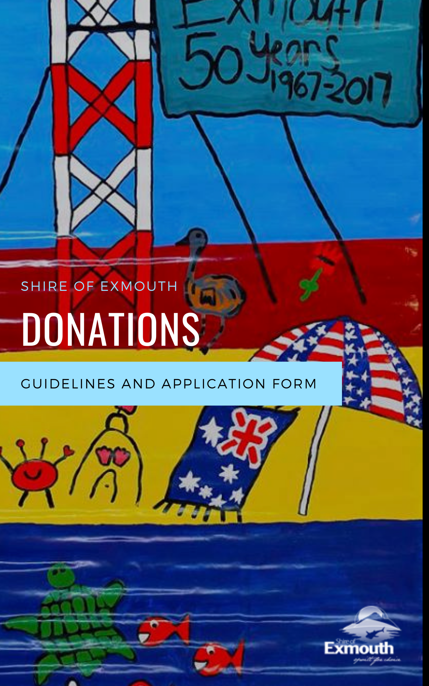

DONATIONS

# Introduction

Small donations up to $500 are available as part of the Shire of Exmouth’s Sponsorship Policy and Guidelines and are designed to meet funding requests that do not meet the eligibility of the MESP and CSGP funding programs.

Funding is available only to not-for-profit and incorporated community or sporting organisations based in the Shire of Exmouth and donations will be available until the grants pool is exhausted.

Requests for donations will only be considered by the Shire President or by delegated authority to the CEO.

Applications should complete the application details below and attach a formal letter of request addressed to the Shire President for consideration and response.

Please note that a maximum of up to $500 per formal request per annum from each entity is allowed and only applications for support of non-core business activities will be considered.

APPLICATION FORM

Please ensure that you have read the donations information sheet and completed the attached application form. We also recommend you contact Shire of Exmouth via [info@exmouth.wa.gov.au](mailto:info@exmouth.wa.gov.au) to discuss your application before applying.

# Organisation information

|  |  |
| --- | --- |
| Name of organisation |  |
| Contact person/position |  |
| Address |  |
| Phone number |  |
| E-mail |  |

|  |  |
| --- | --- |
| I have read the Donation guidelines |  |
| My organisation is eligible to apply for this funding |  |
| Does your organisation have an Australian Business Number? |  |
| Is your organisation registered for GST? |  |
| Has your organisation been granted deductible recipient status? |  |
| Are you an employee or contractor working for the Shire of Exmouth or a close relative? *If yes, we will contact you to determine any potential conflict of interest |  |
| Letter of request attached |  |
| Amount of funding requested? |  |

# Declaration

I, the undersigned, being the      (insert title)       (organisation name), confirm that I have carefully reviewed and considered the responses and the information provided is true and correct.

Signed      Date: Click or tap to enter a date.

Completed applications should be mailed or submitted in person to:

Shire President

Donation Requests

2 Truscott Cres

EXMOUTH WA 6707

Electronic submissions should be e-mailed to [info@exmouth.wa.gov.au](mailto:info@exmouth.wa.gov.au) with subject line: Donation request