GUIDELINES FOR FOOD BUSINESSES

Temporary Food Stalls

May 2019

This guideline has been developed for events that are held away from a permanent kitchen, for example a sausage sizzle, or a food stall. Special care must be taken to keep food safe; this involves protecting the food from sunlight, dust, vermin and handling by customers. Food preparation must only be undertaken by persons who have knowledge and skills in food safety. The Shire of Exmouth provides a free interactive food safety training program called *“I’m Alert*”. This training is available on the Shire of Exmouth's website under Environmental Health and Food Safety. On completion a certificate will be issued which you can use to demonstrate your knowledge of food safety.

Food businesses wishing to sell food at temporary events should contact the Shire prior to operating to check if a permit to trade on public land is required, if an inspection must be completed, if there are any applicable fees and/or if there are any other requirements.

**Email: info@exmouth.wa.gov.au**

**Phone: 9949 3000**

[](http://www.facebook.com/shireofexmouth) **Address**: PO Box 21, 2 Truscott Crescent Exmouth WA 6707  
 **Web: www.exmouth.wa.gov.au**

1. **Personal Hygiene**

The key to safe food is good personal hygiene of everyone involved in the preparation and selling of food. Bacteria that can cause food poisoning are easily transferred from the hands and clothes of people handling the food. It is very important that everyone who handles food have a high level of personal hygiene.

Listed below are some of the main principles of good hygiene for food handlers;

* Always wash hands before handling food. Soap and warm water are to be used and a paper towel for drying hands is to be used;
* Food handlers are to wear minimum jewellery;
* All cuts and wounds are to be covered with a brightly coloured plaster and gloves should be worn for added protection.
* Any food handler who is sick must not handle food;
* Long hair should be tied back or covered;
* Food handlers are to wear clean clothes;
* Food handlers are to wear disposable gloves or utensils where practicable.

1. **Cleaning**

Keeping food preparation areas clean is one of the best ways to avoid food contamination. Thorough cleaning involves removal of dirt and any leftover food, followed by sanitation. It is very important ensure that your food stall is maintained in a clean and sanitary condition at all times.

**Six Steps to Proper Cleaning**

1. **Pre-clean**  Scrape, wipe or sweep away food scraps and rinse with water
2. **Wash** Use hot water and detergent to take off any grease and dirt. Soak if needed
3. **Rinse** Rinse off any loose dirt or detergent foam
4. **Sanitise** Use a sanitiser to kill any remaining germs
5. **Final rinse** Wash off sanitiser
6. **Dry**  Allow to air dry

For additional information on how to sanitize go to DOH website**:** <https://healthywa.wa.gov.au/Safety-and-first-aid/Food-safety>

1. **Food Temperature Control**

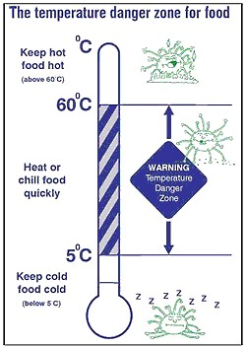To ensure the safety of food, all potentially hazardous foods (PHF) must be kept at either **time or temperature control**.

Examples of **potentially hazardous foods (PHF)**;

* Raw and cooked meats or foods containing such for example casseroles, meat pies;
* Dairy products or foods containing dairy products;
* Processed fruits and vegetables;
* Cooked rice and pasta;
* Processed foods containing eggs, beans or nuts;
* Foods that contain any of the above mentioned, for example sandwiches and quiches.

Bacteria in food can grow to large numbers if they get conditions that suit them. Temperatures between 5°C and 60°C, (temperature danger zone) are ideal temperatures for bacteria to multiply in foods that are potentially hazardous.

**Temperature control:**

Potentially hazardous foods are to be kept at temperatures above 60°C or less than 5°C. A temperature measuring device is required to ensure the food is kept at the appropriate temperature.

**Time control:**

High-risk ready to eat foods may be kept between 5°C and 60°C (in the temperature danger zone) but only in the following circumstances:-

* Up to 2 hours – then it must be refrigerated (<5°C) or used immediately;
* 2 hours up to 4 hours – but it must be used immediately or thrown out;
* 4 hours or longer - must be thrown out.

Note to remember: these times are **cumulative**- each time in the temperature danger zone must be added together, for example from shop to fridge to home and preparation time.

1. **Foods or Ingredients that are known to cause allergic reactions**

10% of children and 3% of adults are susceptible to allergic reactions. If food for sale contains any ingredient on the following list it may cause an allergic reaction for certain susceptible individuals, such a reaction could result in death.

* Gluten (a substance found in wheat, rye, barley, oats and spelt, and therefore present in foods made from these grains and/or made using flour)
* Fish and fish products
* Crustacean (shellfish) and products
* Egg and egg products
* Milk and milk products
* Soya beans
* Sesame seeds or other nuts and products
* Sulphites (a preservative)
* Royal jelly (a secretion from the salivary glands of honey bees)
* Bee pollen
* Propolis (a substance collected by bees)

Should a customer request information about the ingredients of a product, you must be able to provide that information accurately; their life may depend on it. It is a good idea to display the information next to the food or on the packaging.

Note that this guideline is only for food manufactured for sale at community and fundraising events. If you plan to sell food to other businesses or in approved premises, food labelling must comply with FSANZ Food Standards Code. Details about these requirements can be found at [www.foodstandards.gov.au](http://www.foodstandards.gov.au) or contact Environmental Health Services on (08) 9949 3000.

1. **Labelling Guide for packaged food sold at community and fundraising events**

Food labels must include:-

* A description of the food, for example “strawberry jam” or “chocolate cake’”;
* The name and address of the person or company who made the food, so that the maker can be traced if there is any problem with the food.
* A list of ingredients;
* A ‘best before’ date to indicate how long the food will keep; and
* Any special storage conditions, for example ‘keep refrigerated’

A simple handwritten label is acceptable

If you prepare the product yourself, you will know what is in it. If you have used a packet mix just write the ingredients from the packet on your label. Please remember to include any ingredients you made have added, such as eggs.

**Strawberry Jam**

Ingredients: Sugar, Strawberries, Water

Made by: Sam Jones 24 Carr Way, Exmouth WA 6707

Ph: 9949 9999

Best before: 01 Dec 2013 Code 23

Guidelines for the preparation of food for sale from a residential address

The following types of food may be approved for preparation in residential kitchens:

• Cakes (no cream)

• Chutneys

• Jams

• Relishes and sauces that are heat treated

• Biscuits

• Herb vinegars with a pH of less than 4.5

• Pickled Onions

• Muffins

• Chocolate

Other foods may be approved by following written application the Shire of Exmouth Environmental Health Services

1. **Facilities & Stall Construction**

Facilities should be constructed to ensure good standard of food hygiene and allow for easy cleaning and maintenance (see diagram on page 7)

**6a. Equipment**

* Stalls shall consist of a roof and three sides unless all food is otherwise protected;
* Benches or tables are to have smooth and easy to clean surfaces. Plastic tablecloths can be useful;
* Stalls should to be situated on a readily cleanable surface, e.g. concrete, brick, paving, or duckboards where possible. Earthed surfaces - tarpaulins, vinyl or heavy-duty plastic shall be used and the floor covering is to extend beneath all serving tables.
* entire food premises (including barbeques and cool rooms) to be adequately screened to reduce the risk of food contamination and to restrict public access
* Floors to be in the form of a non-absorbent easily cleaned material (e.g. vinyl) cut larger than the floor area to enable it to be turned up at the wall and clipped or fixed into position. Floors in multi day events should be raised to account for wet weather, and should consider high traffic areas i.e. between the stall and cool room.
* Walls & ceilings to be non-absorbent easily cleaned. The framework of the wall panels should support the fabric taut and rigid. No part of the walls should flap in the breeze or be unsecured
* Whole structure to be securely fixed together when assembled and protected against wind.
* 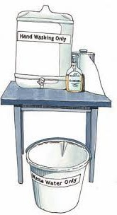Food preparation surfaces (e.g. counters, shelves, stands) must be made from rigid, smooth and durable material, free of cracks or joints. Timber surfaces should be painted, laminated or clear finished. Shelves should be at least 150 mm off the floor to avoid cross contamination and facilitate effective cleaning and sanitising. Metal end sections should be sealed.

**6b. Washing Facilities**

* Separate facilities for hand washing and utensil washing are to be provided within the stall
* Single use hand towels, liquid soap and detergent are to be on site and accessible for immediate use.

**Example of appropriate hand wash station**

**6c. Protection of Food**

* All food stored inside the stall is to be stored above the ground and covered or in closed containers;
* Disposable eating utensils only are permitted to be provided to customers;
* Disposable-eating utensils are to be pre-wrapped in paper napkins, or similar material;

**6d. Cross Contamination**

Raw food can contain bacteria which causes food poisoning. The bacteria present in raw food can contaminate cooked ready- to- eat foods. Therefore; it is extremely important to ensure raw food items are kept separate from cooked foods. Equipment used to prepare raw foods must be sanitised and separate utensils must be used for raw and cooked foods.

For pre-packaged and low-risk foods at single day events, there may be exemptions from certain construction requirements due to the reduced food safety risk. Contact the local council to enquire about exemptions. Examples of pre-packaged and low-risk foods are: pre-bottled or sealed jams, honey, pickles and drinks; pre-wrapped and sealed cakes, toffees and biscuits; whole fruit, vegetables and nuts intended to be washed or peeled before eating.

The preparation and display of food, including unpackaged ready-to-eat food, must be protected from likely contamination from customers. Sneeze barriers or other enclosures should be considered.

**6e. Pests**

* Watch out for pest activity and take appropriate action to eliminate the pests and discard any damaged or contaminated food;
* Animals must not be allowed to enter the food stall and service area at any time.

**6f. Rubbish Disposal**

* Suitable rubbish receptacles are to be provided near the stall for the public to dispose of rubbish;
* Adequate arrangements are to be made for the frequent removal of garbage generated inside and outside the food stall.

**Temporary Food Stall Layout**

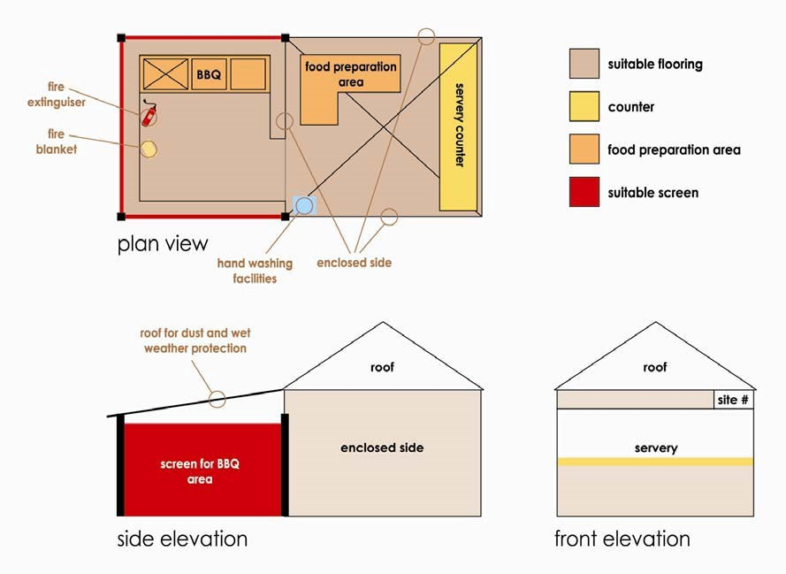

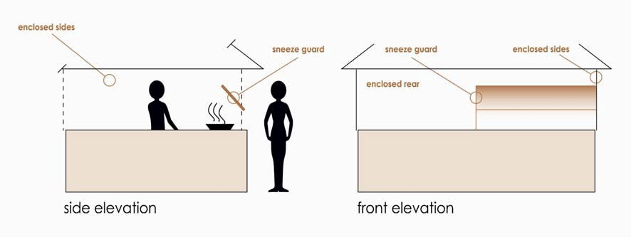

**Temporary Food Stall Checklist**

Name of Stall: _______________________________________

Owner/operator: ____________________________________

**Type of Food Product Sold**

* Pre-packaged food only
* Unpackaged food product

**Structure**

* Enclosed stall (roof and three sides) –easy to clean, impervious material e.g. vinyl sheeting. Roofing may not be required where.
* Adequate roofing provided when located in existing structure; or
* All food product is pre-packaged (no taste testing).
* Floor covering- easy clean, impervious material e.g. vinyl flooring. Note. Must be provided when located on unsealed ground.
* Adequate natural or artificial light must be provided for activities conducted in the stall.
* Barrier between stalls and public.

**Stall Equipment**

* Cooking equipment located to protect food from contamination
* A minimum of 20L potable water in a container with a tap to be provided for washing purposes. With basin or bowl for washing
* Dispensable soap or disinfectant and sufficient quantity of disposable hand towels or wiping cloths.
* Note: the above mentioned to be stalled above the ground, on table or bench separate from all food products.
* Lidded fly proof receptacle, of sufficient size, for disposal of rubbish and/or food scraps
* Dry chemical fire extinguisher and fire blanket (only required for full preparation of food)

**Food Preparation and Storage**

* Food preparation to be kept to the bare minimum. Only assembly of components may be permitted if approved by EHO.
* Separate raw and cooked foods.
* Food covered
* No food stored directly on the ground.

**Management of Stall**

* Food Handlers to be neatly and cleanly dressed at all times. (Hair tied back or covered with cap of hat.
* Cups, plates, knives, forks, used by public to consume food are to be single service articles. **Food handlers must hand these out to customers.**
* Work and servery areas to be kept clean and well-ordered at all times.
* Stall to be arranged in a manner to prevent the public from entering behind the table or bench, or handling food prior to purchase.
* Staff handling food are not to handle money at any time. A separate person is to collect money only.
* No smoking whilst preparing or serving food.
* All directions of Environmental Health Officer are to be followed.

**Waste Management**

* Refuse bins with lit and container supplied.
* Waste water stored in container clearly labelled ‘waste water only’ and be disposed of correctly.
* Waste oil stored and disposed of correctly.

**Comments/ Notes**

______________________________________________________________________________________________________________________________________________________________________________________________________________________________________________________________________________________________________________________________________________________________________________________________________________________________________________________________________________________________________________________________________________________________________________________________

**Contacts and More Information**

Shire of Exmouth [www.exmouth.wa.gov.au](http://www.exmouth.wa.gov.au)

Department of Health <https://ww2.health.wa.gov.au/>

Food Standards Australia & New Zealand [www.foodstandards.gov.au](http://www.foodstandards.gov.au)

Food Safe Online Training; <https://www.ehawa.org.au/products/foodsafe-products/foodsafe-online>